**Brilliance in Black**

**Black Restaurant Week - Baltimore**

**2018 Restaurant Participation Packet**

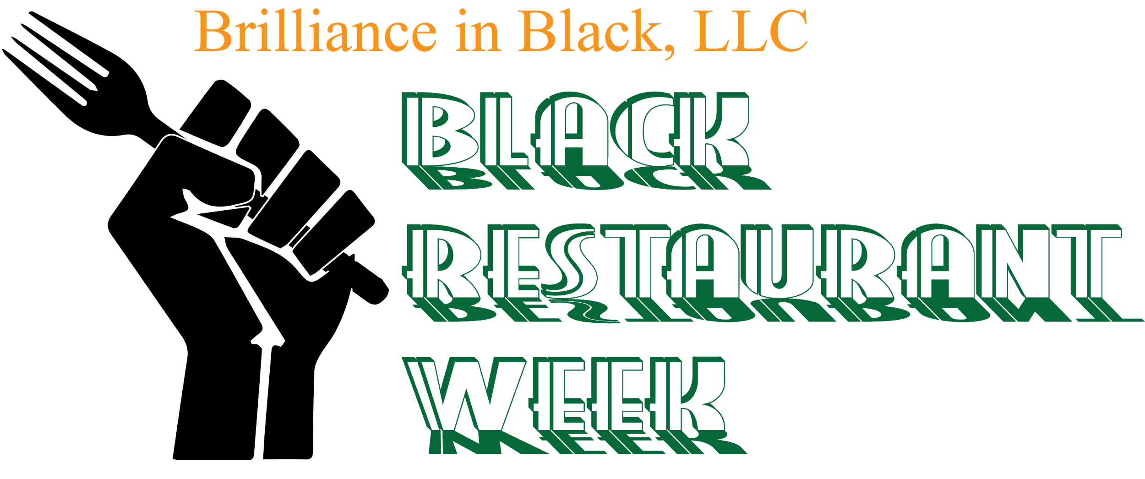

**Contact: Kiana Ebone’**

[**BrillianceinBlack@gmail.com**](mailto:BrillianceinBlack@gmail.com)

**About Black Restaurant Week- Baltimore**

Brilliance in Black, LLC is dedicated to highlighting the positive actions of those in the community, as well as, promoting black businesses. We understand the importance of circulating the black dollar to stimulate and uplift socio-economics. As an extension of our Baltimore Black Wall Street Festival, we have created Baltimore Black Restaurant Week. Our goal is to create an opportunity for black owned restaurants to generate new customers through a week of dining deals. A portion of the proceeds raised during Black Restaurant Week will be donated to #FIXBaltimore, “a community organization and urban empowerment group that aims to improve the community through artistry, volunteering, workshops, community gardening and city cleanups.” (<http://fixbaltimoreweb.wixsite.com/home>)

**June 3-10, 2018**

Brilliance in Black Baltimore Black Restaurant Week is a city-wide celebration of African-American owned restaurants. For the week of June 3-10, diners will be able to enjoy the culinary cuisines of participating Black owned restaurants. Menus range from $15-$35.

**PARTICIPATING RESTAURANT DETAILS**

Sign a copy of the Restaurant Agreement at the end of this packet to submit your information and menu. The deadline for submissions is **May 6, 2018.**

**APPLICATION**

**Website:** [**www.BrillianceinBlack.com/BRW-Baltimore**](http://www.brillianceinblack.com/BRW-Baltimore)

**Email:** [BrillianceinBlack@gmail.com](mailto:BrillianceinBlack@gmail.com)

**Phone:** (410) 204-4838

**Participating Restaurant FAQ Sheet**

**Participation Cost**

Black Restaurant Week- Baltimore participation requires a fee of ~~$200~~  **$125**, used for promotional and marketing efforts. Brilliance in Black will provide restaurants with custom menus, as well as, printed and digital marketing material.

**What Should Be Included in the Prix-Fixe Menu?**

Participating restaurants are able to select their own menu items and offerings, offering a two or three course menu to diners.

**What is Included in the Restaurant Brilliance Kit?**

The purpose of Black Restaurant Week is to bring light and awareness to the number of black owned restaurants in Baltimore; we will provide restaurants with a “Brilliance Kit” including:

* Custom Printed Menus
* Brilliance in Black Baltimore Black Restaurant Week Table Tents
* Custom Promotional Digital Flyers

**Sample Menu Sample Digital Flyer**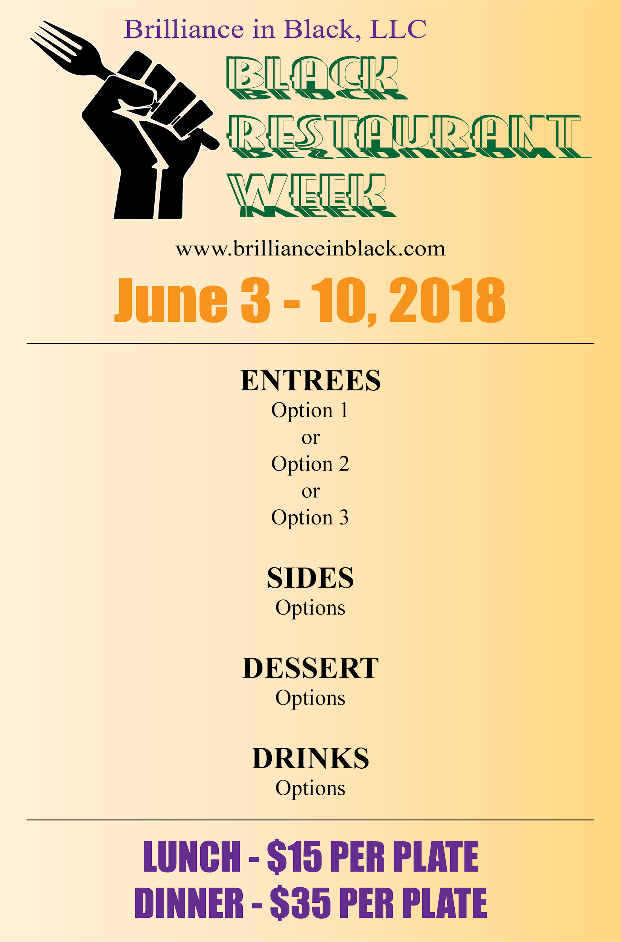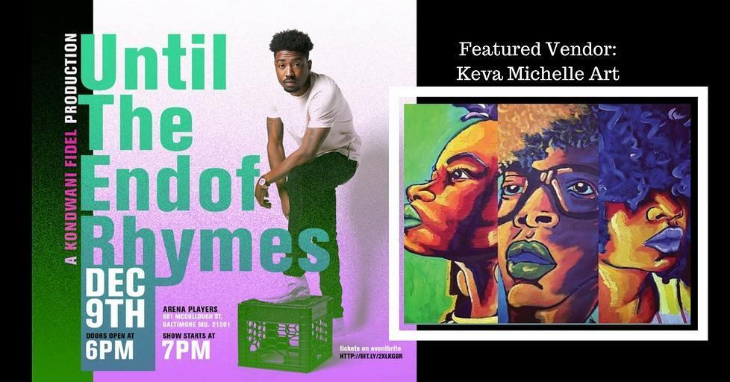

**Black Restaurant Week Events**

As a part of Brilliance in Black’s restaurant week, we will host 3 events(location TBD). If you are interested in being the host restaurant for any of these events, please let us know as soon as possible.

***See flyers below***

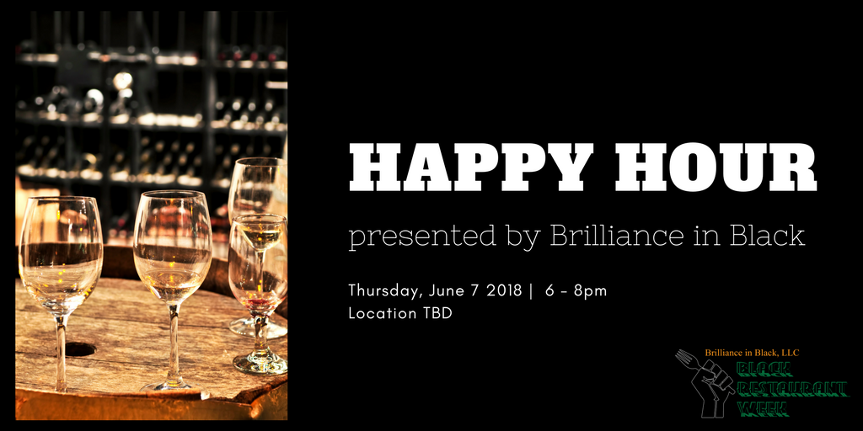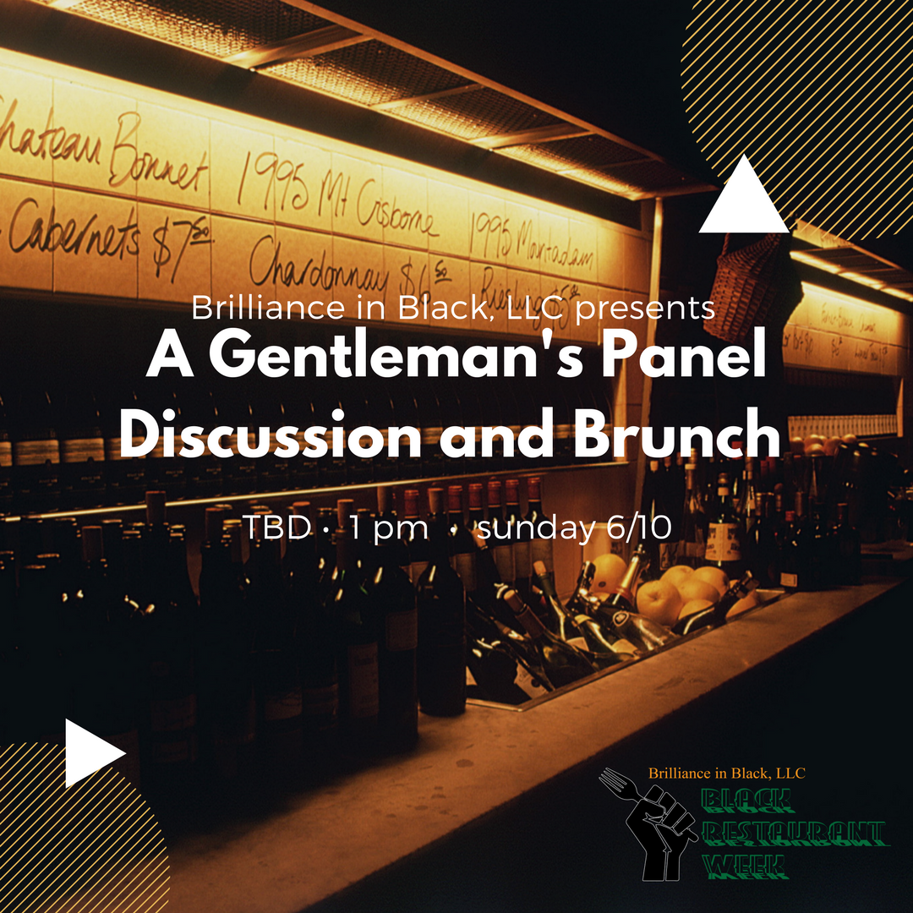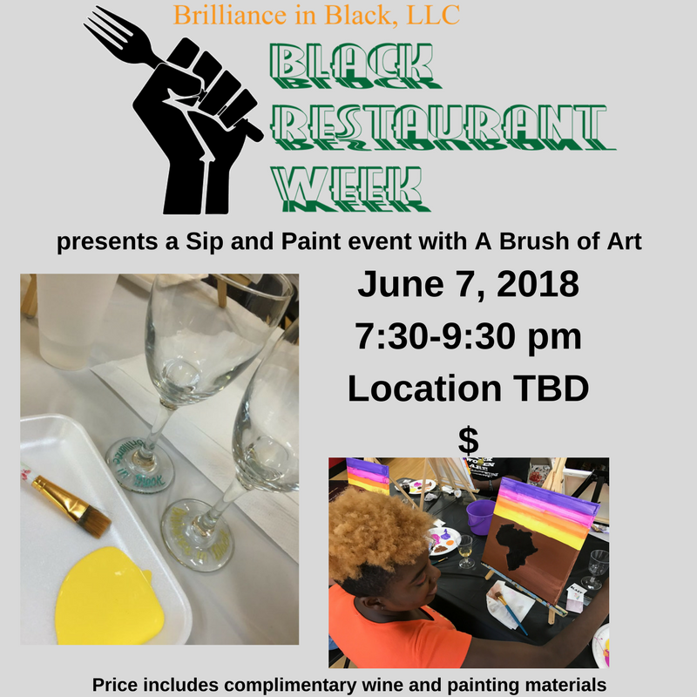

**Brilliance in Black, LLC**

**Black Restaurant Week**

Indemnity and Performance Agreement

**Date Services Performed For Services Performed By**

**June 3-10, 2018 __________________ Brilliance in Black, LLC**

**(Restaurant Name)**

**Agreement (the “Agreement”) between __________________________ (Restaurant Name) of _________________ (address) and Brilliance in Black, LLC, P.O. Box 802, Randallstown, MD 21133 dated ___________________ (today’s date).**

**The Parties herein agree to the follolwing:**

**The term of this Agreement will be June 3, 2018 through June 10, 2018.**

**Black Restaurant Week runs from June 3, 2018 through June 10, 2018. By entering this Agreement, you become a participating restaurant and agree to offer your restaurant services to participating patrons according to the terms herein. As a participating restaurant, you agree to create a pre-fixe menu for patrons valued at $15-$35 during Black Restaurant Week.**

**In exchange for inclusion, participating restaurant agrees to pay Brilliance in Black, LLC a fee of TWO HUNDRED DOLLARS ($200), to be paid at the time of registration and within 2 weeks prior to the start date of Black Restaurant Week.**

**The fee to be paid by the participating restaurant to Brilliance in Black, LLC will provide the following:**

* **Addition to the Brilliance in Black, LLC Black Business Directory**
* **Pre and post Black Restaurant Week coverage**
* **Marketing on print and social media**
* **Respective logos on print and electronic material**

**Participating Restaurants will be responsible for the following:**

* **A fixe-price multicourse meal to be submitted to Brilliance in Black, LLC by May 13, 2018. Each participating restaurant will be allocated 50 menus, additional menus can be purchased for an additional charge.**
* **Must participate on its regular operating schedule, for the dates of June 3-10, 2018**
* **Must display marketing materials to patrons and offer the Black Restaurant Week menu as an option for all patrons.**

**Registration fees paid between Brilliance in Black, LLC and Participating Restaurants are non-refundable.**

**PARTICIPATING RESTAURANT BRILLIANCE IN BLACK, LLC**

**By: __________________________________ By: ________________________________**

**Name: _______________________________ Name: _____________________________**

**(Name and Title) (Name and Title)**