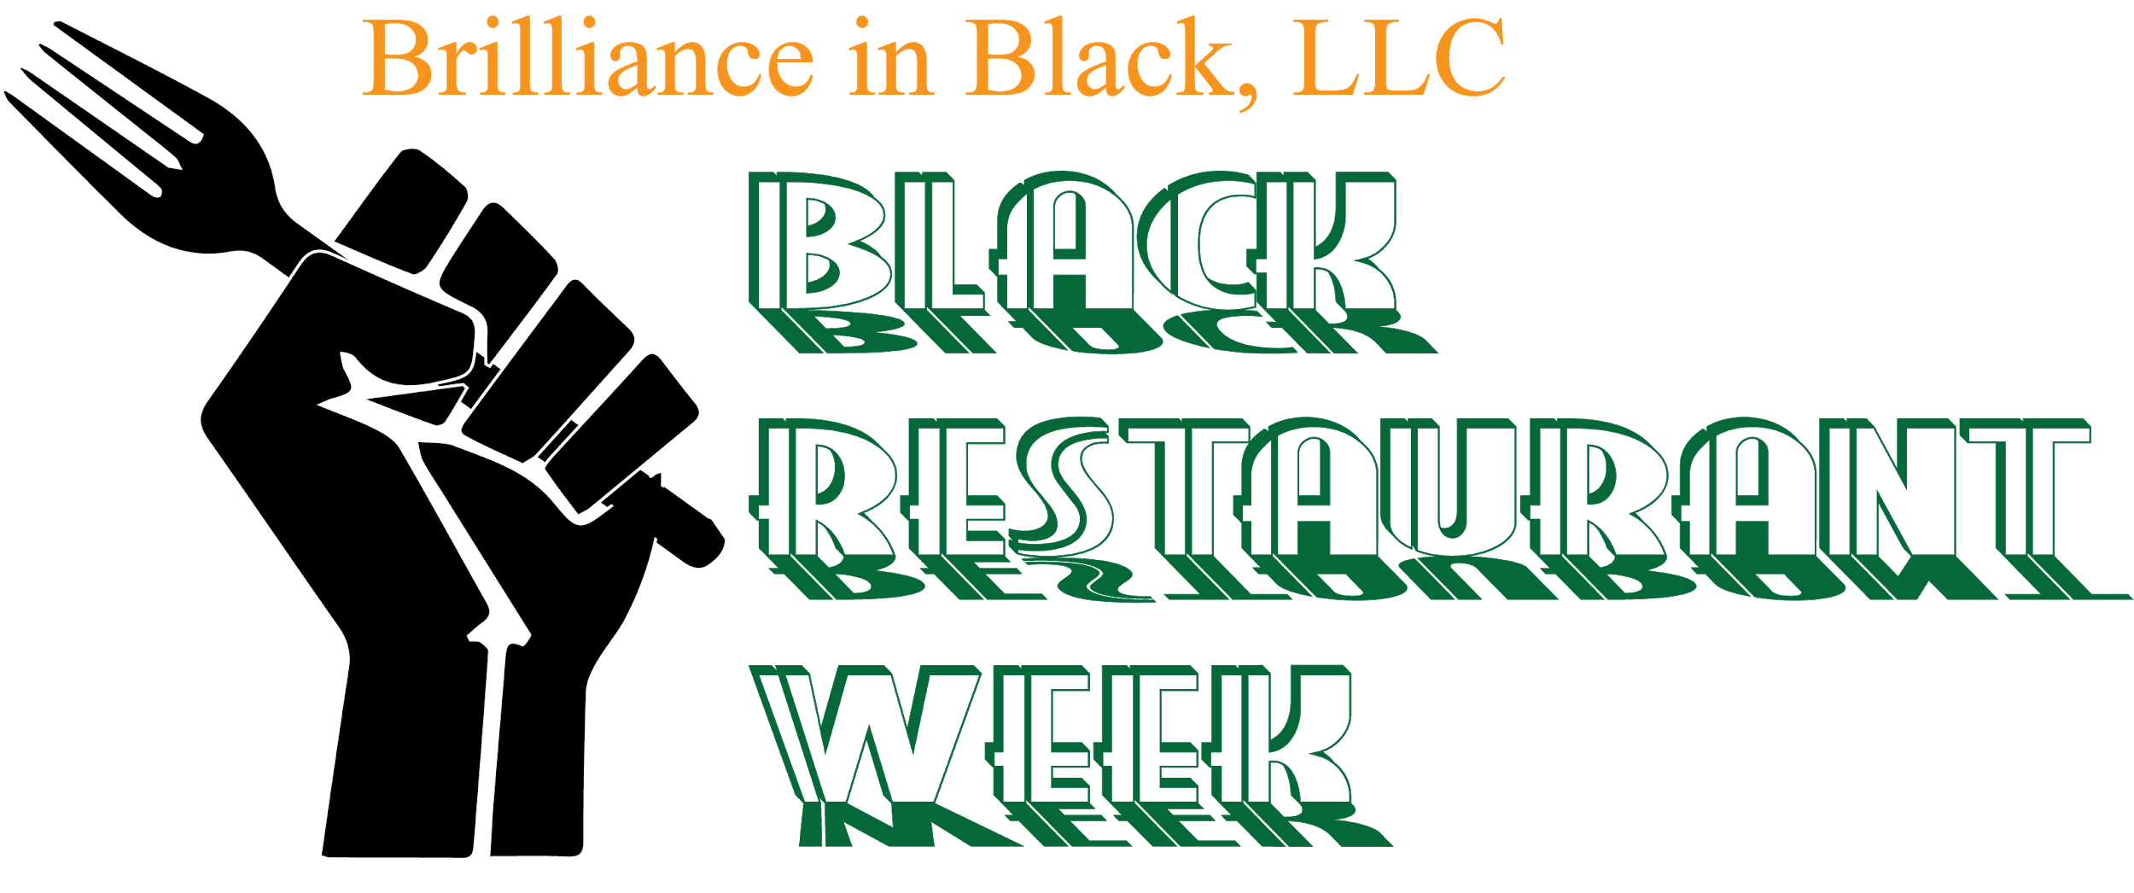

2018 SPONSORSHIP PACKET
EVENT DATE: JUNE 3-10, 2018

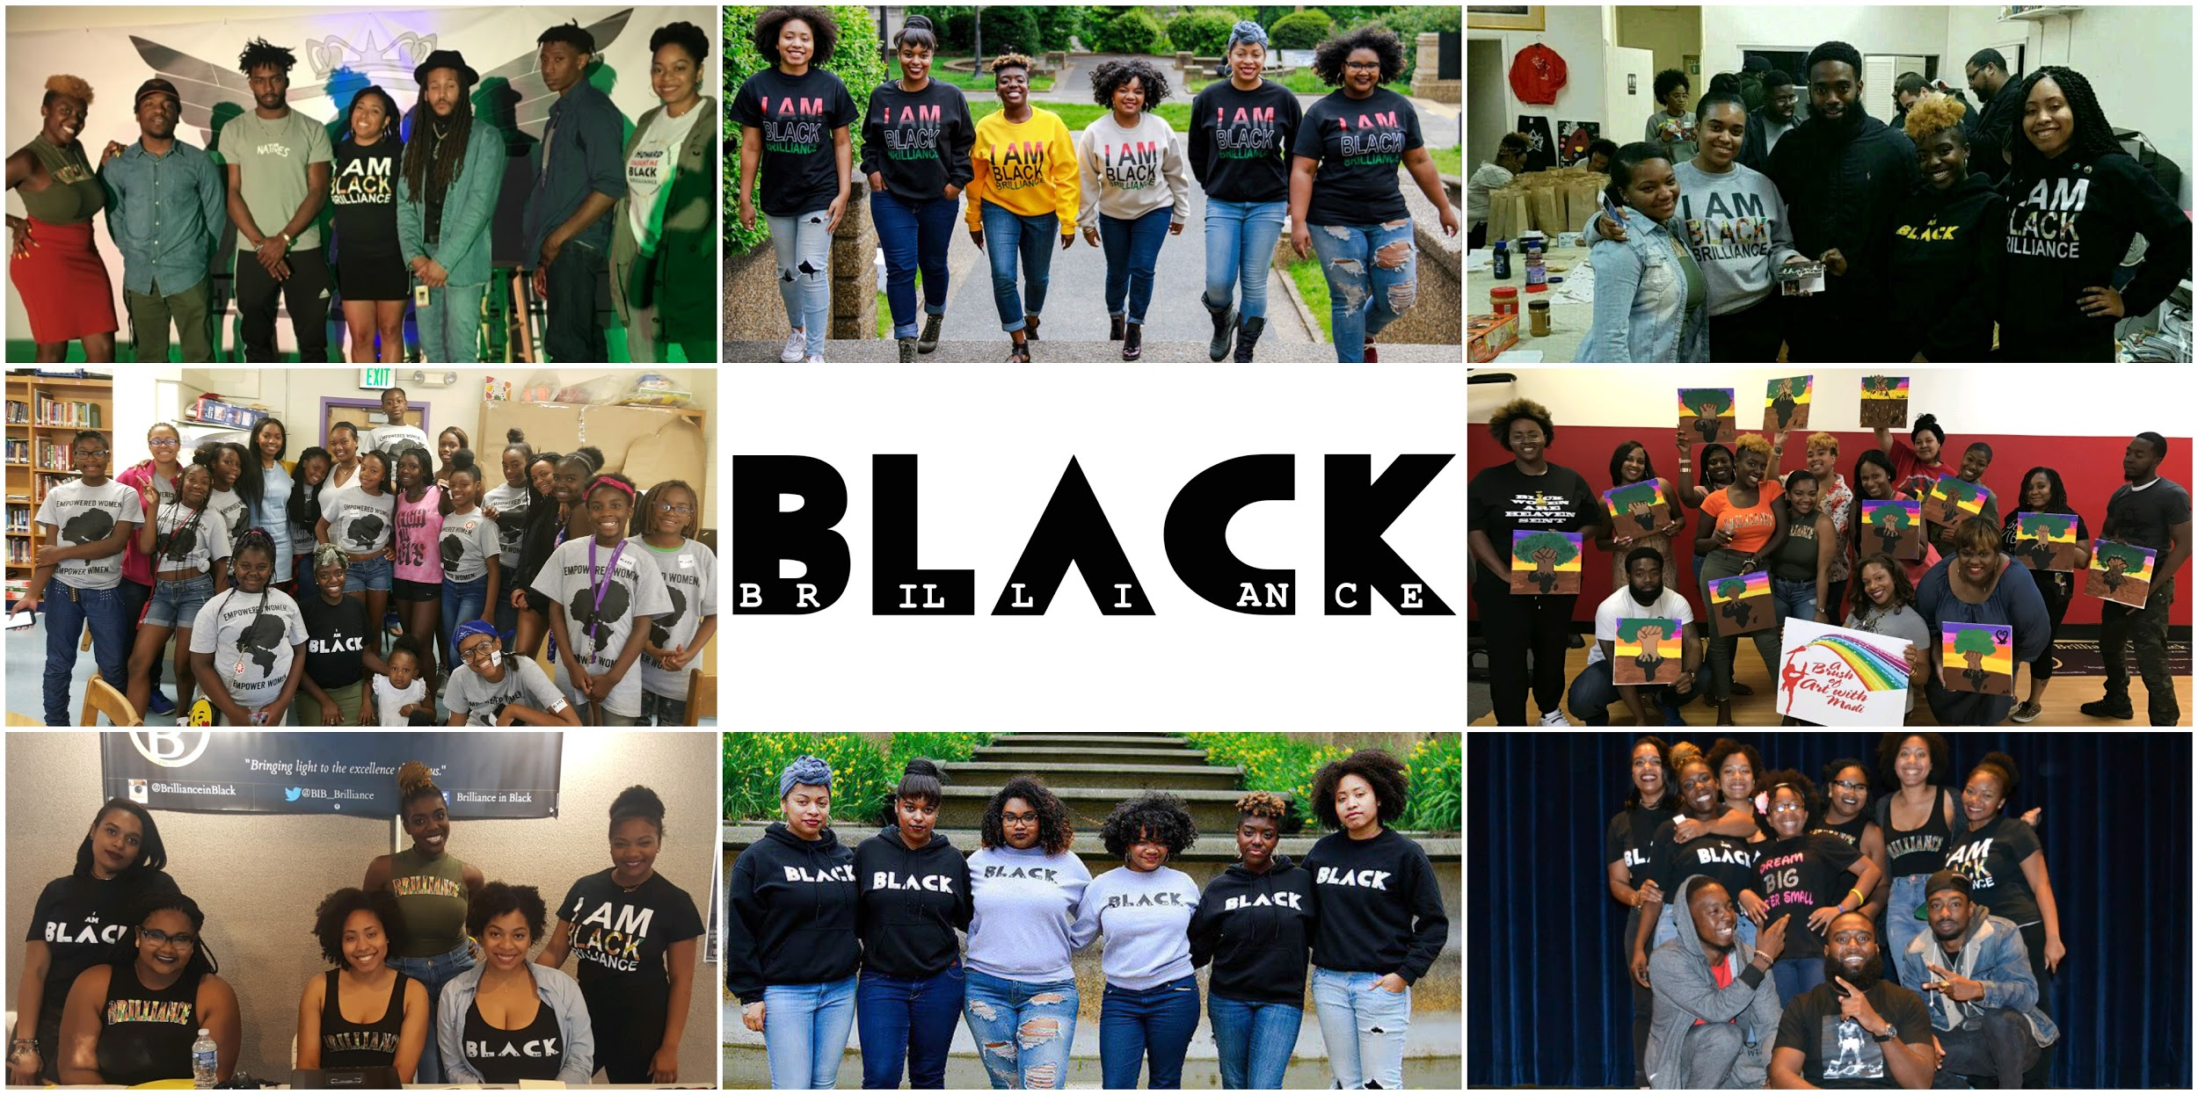

To Our Prospective Sponsors and Corporate Exhibitors:

Thank you for your support and dedication to promoting and supporting black businesses in the city of Baltimore. With the support of community building and sponsors in the Baltimore area, the Baltimore Black Restaurant Week will not only bring light to the growing number of black owned businesses here in the city, but also aid in creating a network to support and build the city.

The Baltimore Black Restaurant Week is scheduled for June 3-10, 2018, and is hosted by Brilliance in Black, LLC.

Your affiliation with our event will compliment your established reputation of excellence in the community. Given the importance of this festival, we ask that you make a sponsorship commitment on behalf of your company or organization. Your funds will aid in offsetting the expenditures associated with the event, as well as media coverage, and assist in the promotion of black businesses throughout the state of Maryland. We are relying on your sponsorship to help us offer diners an exciting experience to be remembered!

In the following pages of this sponsorship packet you will find detailed information about the event and how you, as a sponsor, can receive the maximum benefits and exposure. If you have any questions or require our assistance, please do not hesitate to contact us at the phone number or email address below.

Thank you and we look forward to working with you!

Sincerely,
Kiana Ebone’
Brilliance in Black Co-Founder
Baltimore Representative
(410) 204-4838
BrillianceinBlack@gmail.com

2018 Black Restaurant Week
Sponsor Promotions

Promotions of the Baltimore Black Restaurant event include a combination of print, web and media coverage prior to, the day of, and following the event. Here are some samples of prospective 2018 promotional items:

Website & Social Media
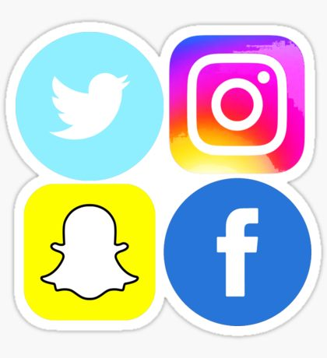
Social Media Stats

Facebook
www.facebook.com/BrillianceinBlack
2,000 Followers

Most Popular Age Group
25-34 years old

Instagram
@BrillianceinBlack
2400 Followers

Twitter
@BIB_Brilliance
240 Followers

Snapchat
blvckbrilliance

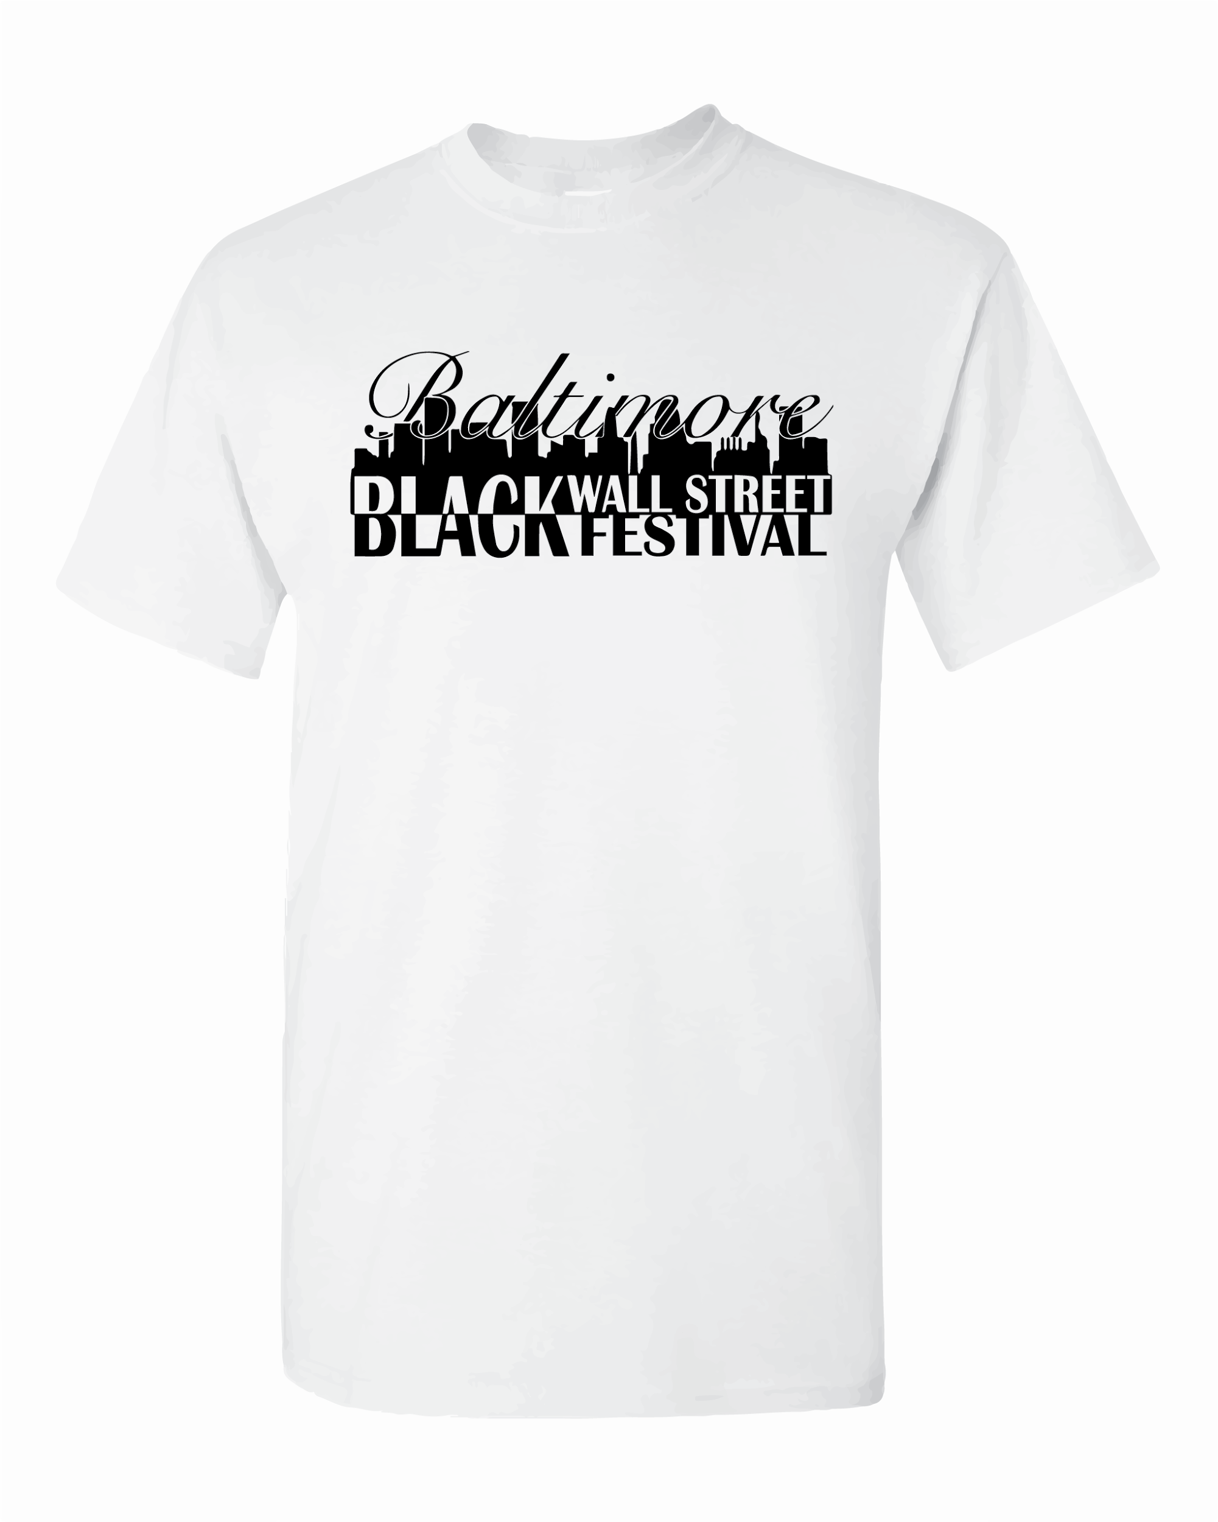
Tshirts
The official Baltimore Black Restaurant Week T-shirt Features the Festival logo on the front and Sponsor Logos on the back. Sponsors, restaurant owners, and volunteers will receive shirts and will be available to purchase at www.BrillianceinBlack.com

Radio & Media Coverage

Radio:
92q is the largest radio station in Baltimore, reaching 90% of population. For a full promotional schedule, ads running 3-4 times a day for the two weeks leading up to our event, cost between $2000-$2500.
Magic 95.9 reaches 60% of the population, catering to an older demographic. The cost for a promotional schedule is between $1500-$2000.

Media:
Coverage for the event will include newspaper ads and Press Coverage leading up to the day of and following the event. Samplings of an article written about a previous Brilliance in Black event is in the final pages of your Sponsor Package.

2018 BALTIMORE BLACK RESTAURANT WEEK
SPONSORSHIP OPPORTUNITIES

Diamond
$2500
- Company promotion on media & radio promotions
- Company logo on promotions
- Banner at BRW events
- Exclusive vendor space at BRW events

Platinum
$1000
- Company logo on promotions
- Banner at BRW events
- Exclusive vendor space at BRW events

Gold
$500
- Company logo on promotions
- Banner in event venue

Silver
Sponsor a Restaurant
$200
- Company logo on promotions

2018 BALTIMORE BLACK RESTAURANT WEEK
THANKS & CONTACT

The Baltimore Black Restaurant Week is an event created to encourage support of black owned restaurants and to build a network of black business owners from and around Maryland, that will work together to build our communities. It is our mission to bring light to the excellence here in Baltimore, and its surrounding areas. As we continue to spread the positive actions of those in our communities, we invite you to be a part of an event important to the economic development of the black community. Our first Black Restaurant Week will be an event for diners to share, learn, and network, while also focusing on the circulation of the black dollar.

On behalf of Brilliance in Black, LLC, we would like to take the opportunity to thank you for your consideration as a Sponsor. Through your sponsorship this event will truly flourish and set up an opportunity for many more events to service our community. We look forward to including you as a partner for our 2018 event!

Brilliance in Black
and the Baltimore Black Wall Street Festival Committee

Contact us about your sponsorship:
Kiana Eboné (410) 204-4838 BrillianceinBlack@gmail.com

2018 Baltimore Black Restaurant Week
Sponsor Agreement

Contact Name ___________________________________________________________
Title ___________________________________________________________________
Company _______________________________________________________________
Address _____________________________City______________St__________Zip___
Telephone _______________________________________________________________
Email___________________________________________________________________

I agree to be a Sponsor in the following category:
- □ Diamond
- □ Platinum
- □ Gold
- □ Silver
- □ Other (specify here) _________________________________

Brilliance in Black, LLC agrees to provide the benefits described in your sponsorship category.

Payment Information:

___ Check Enclosed Amount $_________
___ Paypal Amount $_________ Verification Code_____________

By: ________________________ Date: _______________________

BrillianceinBlack@gmail.com

Please make checks payable and return this form to:

Brilliance in Black, LLC PO Box 802 Randallstown, MD 21133

#ArtforJustice discusses current events through creativity
Jacob deNobelContact ReporterCarroll County Times
http://www.carrollcountytimes.com/publications/community_times/ph-ct-art-for-justice-20161011-story.html
Artists will have the space to express themselves about current events and tragedies on Saturday evening at Brilliance in Black's first-ever #ArtforJustice arts benefit showcase at the Garrison Forrest School.
Brilliance in Black was formed by six Howard University alumni last year after the deaths of Mike Brown in Ferguson, Missouri, and Freddie Gray in Baltimore. Their website describes their mission "to highlight and support all positivity done by African Americans in our communities." According to Kiana Ebone, co-founder and chief brand officer with the group, the organization was born out of discussions of what to do next.
"We came together in the heat of the moment," Ebone said. "We were discussing all of the things going on in the world, and knew we wanted to push out a positive image. Brilliance in Black was formed to highlight the positive actions going on in the black community."
The #ArtforJustice showcase will feature artists including poets, singers, rap artists, dancers, authors, and painters coming together to express their feelings and takes on the world around us. Ebone is a dancer who teaches throughout Baltimore City Public Schools and dance studios around the area. She said an artist's view on the world can be a vital tool for justice.
"What I love most about dancing is that it's my way of speaking," Ebone said. "It's my voice in any situation. There are so many ways to express yourself and still convey a message or still convey a story."
Ebone said that although not everyone is meant to lead a march or protest, artists can help advocate for justice through their work. She said they hope to have a dialogue with visitors at the end of the program, because it can be easy to tune out what is going on in the world, though it's important to stay engaged.
"I think that art always sparks a conversation," Ebone said. "Art causes people to talk. Art sparks new art. A conversation was the first step to how we got started. It's always the first piece to a movement until you get to the next."
This is the largest event Brilliance for Black has put together yet. In the past, they've organized a holiday giveback, a 1-year anniversary and several scholarships. Ebone said it's exciting to watch the group expand, with many of the artists involved in the #ArtforJustice showcase new to the group. She said it's a sign the organization's horizons are broadening.
"We all have a piece that we can put to this puzzle," Ebone said. "No matter what you do; no matter what your calling is, everyone has a place in the movement."
In the future, Ebone said they hope to put together larger galas to afford to increase their scholarships and give more back to communities. The goal for the group is to expand their network into cities across the country to get their message out to as many people as possible.
"We need to push these positive stories," Ebone said. "There's so much negativity out there, and with social media these messages are getting pushed out so quickly. We want to get our message out there just as much. There are beautiful things happening in our communities."
Jacob.deNobel@carrollcountytimes.com
410-857-7890
Twitter.com/Jacob_deNobel

Kiana Chase-Mercer ’09 Joins BSA for Brilliance in Black Vision Board Party
https://www.gfs.org/news/posts/~news-id/31
Last Friday, Kiana Chase-Mercer ’09 joined the Garrison Forest Black Student Alliance to lead a vision board party at GFS through her organization, Brilliance in Black. Founded by six Howard University alumnae, Brilliance in Black’s mission is to support and highlight the positive actions and gifts of those in the Black community through the implementation of organized programs and events.
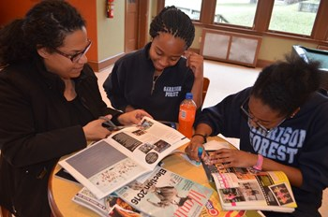
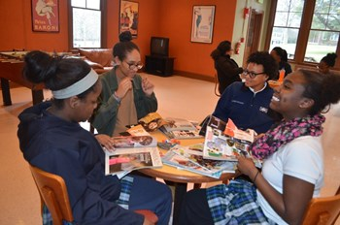
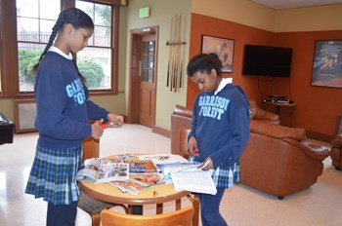
The group of mostly Upper School students (a few Lower and Middle School students and faculty and staff members attended also) gathered in the O’Zone to create their vision boards. Using magazines, construction paper, and colored pens and pencils, attendees created a wide variety of boards to represent their hopes, dreams and aspirations toward a great future.
